**Road Pulse**

**Final Year Project Proposal**

**Session 2017-2021**

A 4th Year Student

A project submitted in partial fulfilment of the

COMSATS University Degree

of

BSc. (Hons.)BS in Computer Science (CUI)



Department of Computer Science

COMSATS University Islamabad, Lahore Campus

03 January 2021

**Project Registration**

|  |  |  |  |  |  |  |  |
| --- | --- | --- | --- | --- | --- | --- | --- |
| Project ID (for office use) | | |  | | | | |
| Type (Nature of project) | | | [●] **D**evelopment [] **R**esearch [] **R**&**D** | | | | |
| Area of specialization | | | Digital Image Processing and Deep Learning | | | | |
| **Project Group Members** | | | | | | | |
| Sr.# | Reg. # | Student Name | | CGPA | Email ID | Phone # | Signature |
| (i) | SP17-BCS-085 | Hamza Latif | | 2.69 | hamza.latif773@gmail.com | +92 3157129259 |  |
| (ii) | SP17-BCS-058 | Hassan Sharjeel | | 2.89 | hsjoiya@gmail.com | +92 3348217107 |  |
| Name & Signature of Batch Advisor  (If students are eligible for FYP) | | | | ZAHEER AHMAD GONDAL | | | |

**Plagiarism Free Certificate**

This is to certify that, I am **HAMZA LATIF** S/o **MUHAMMAD LATIF** group leader of FYP under registration no **CIIT/SP17-BCS-085/LHR** at Computer Science Department, COMSATS Institute of Information Technology, Lahore. I declare that my FYP proposal is checked by my supervisor and the similarity index is ________% that is less than 20%, an acceptable limit by HEC. Report is attached herewith as Appendix A.

Date: **09/02/2020** Name of Group Leader: **HAMZA LATIF** Signature: _____________

Name of Supervisor: **DR. Usama Ijaz Bajwa** Co-Supervisor (if any): ____________________

Designation: **Asst.Professor and Associate HOD** Designation: _____________________

Signature: _____________________ Signature: _____________________

**Approval of FYP Management Committee**

Committee Member 1: Name: _____________________

[ ] Accept [ ] *Defer [ ] *Reject Signature: _______________

*Remarks: _____________________________________________________________________

Committee Member 2: Name: _____________________

[ ] Accept [ ] *Defer [ ] *Reject Signature: _______________

*Remarks: _____________________________________________________________________

Convener: Name: _____________________

[ ] Accept [ ] *Defer [ ] *Reject Signature: _______________

*Remarks: _____________________________________________________________________

Table of Contents

1.1 Project Abstract 4

1.2 Introduction 5

1.3 Motivation and Scope 6

1.4 Work done Related to Project 7

1.4.1 Embedded Camera for Traffic Surveillance using Video Analysis 7

1.4.2 Accident detection and Traffic monitoring 7

1.4.3 Traffic Violation Detection System 7

1.5 System Architecture 7

1.6 Goals and Objectives 8

1.7 Individual Tasks 9

1.8 Gantt Chart 10

1.9 Tools and Technologies 10

2 References 10

Table of Figures

Figure 1 :Basic System Module diagram 6

Figure 2: Basic Working Flowchart of our Architecture 8

## Project Abstract

Safety and comfort of road users is a matter of great concern. Due to increase in traffic violation police enforcement is necessary element in road safety. It is essential to build a safer and much more reliable and efficient traffic control and management system to avoid tragic events like accidents etc. We try to propose a system which can detect traffic violations like speed violation, stop line violation, red line violation etc. According to different road conditions our system will be able to provide an estimation of speed limit, vehicles count and accidents prediction. Traffic violation detection system is an effective tool to help traffic administrators so a particular action can be taken in real time

## Introduction

Violation of traffic rules is a critical and rising issue presently. Fast reaction and prevention of traffic violation plays a key role to ensure safety of vehicles and citizens. For this purpose, in Pakistan surveillance cameras are installed everywhere to prevent traffic violations but they are unable to detect events like red-light violation, wrong way driving etc. due to the faulty architecture. In Pakistan traffic issues are rising day by day which are causing many causalities like accidents, loss of innocent lives and compromise in safety of citizens. Recently a survey related to the accidents causing deaths in Pakistan increases dramatically due to the traffic violations. [1].So to minimize such alarming factors we should provide an automated solution using latest technology which will help to reduce these factors.

Rising traffic congestion [2],rules violation and accidents [3] due to lack of proper traffic management and surveillance need to be addressed with smart solutions. Like automated detection of rules violations, vehicles congestion etc. integrated with video analytics that can effectively aid traffic administration.

By implementing such system labour cost can be reduced. Reduction in labour will also eliminate many other factors like lack of attention while monitoring many cameras at the same time, pin pointing such events when and where are they happening etc.

Automatic traffic violation in Video analytics using can play an important role in getting in-depth insights into traffic conditions [4] and these insight can help by routing this information to traffic administrators which can take an effective action on any type of event. Surveillance cameras are cheap and ubiquitous, but the labour required for monitoring them increases the cost now a day. Because generally it happens that the surveillance cameras are not monitored by proper attention and it is also difficult for a person to pin point a violation between large number of screens. Usually, either no video is monitored at all or infrequent video is observed, alternatively it is used only for reviewing the incident just for once. But they are also helpful as they are capable of detecting events instead of passive recording. They make use of the events as they appear to happen and in accordance to it, take appropriate actions such as alerting the traffic management department. This is the utmost requirement of automatic violation detection system.

So, our main objective is to derive an optimized and effective solution in traffic violation matter which can detect any type of violation such as red light violation, wrong-way vehicle detection, over speeding and stop line violation etc. Our proposed system will be flexible in nature. Flexibility allows user add new module to system easily. Some other information can also be infer from this system like vehicle count, provide a prediction of an accident using traffic pattern etc. This system will help the Traffic management authorities in accurate violations detection so proper action can be taken in real time and prevent accidents and guarantee citizens safety.

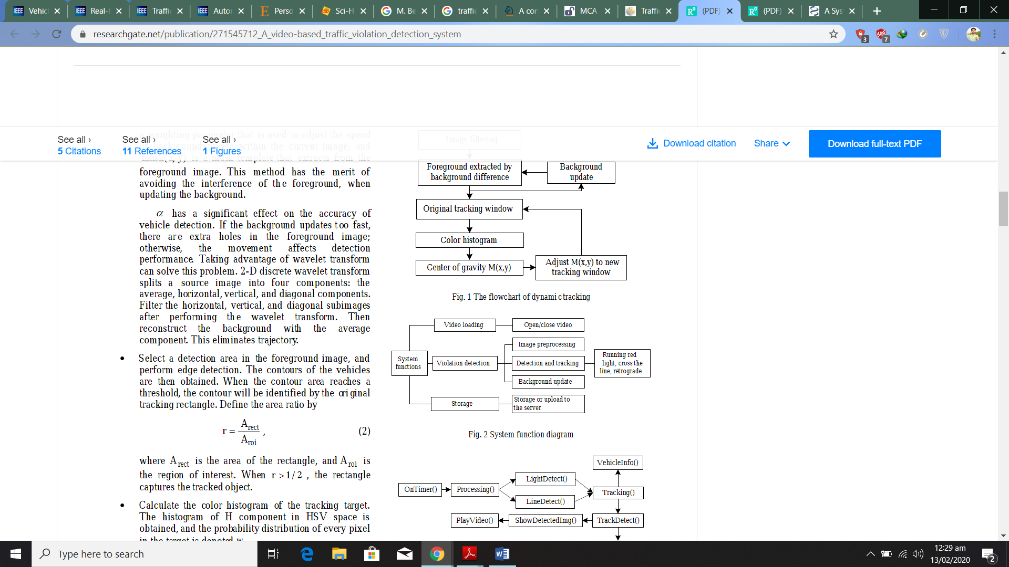

Figure 1 :Basic System Module diagram

Machine learning algorithms and digital image processing methods are being used for these types of problems [5] still there are many complexities which require greater computation and adaptiveness in algorithms which is possible but are time taking

They are many solutions proposed to detect the abnormal patterns in traffic but they require proper guidance how to interact with application’s UI, costly hardware such as costly sensors to detect any type of violation and heavy GPU for processing video streams and are cost effective. So we try to propose a system based solution by training our model with latest and 3 to 4 types of datasets which will cover all type of traffic violation. The system will be cheaper eliminating the costly hardware like GPU’s, sensors etc. Other factors are discussed below.

## Motivation and Scope

The main motive to design and develop such system is to reduce the amount of road accidents by ensuring proper traffic regulation and management. Reduction in number of road accidents will result in the reduction of human injuries, death rate and financial loss.

This system will also help and assist law enforcement agencies to minimize the traffic violations which will ultimately reduce the risk factor for pedestrians etc. Accuracy and quick processing will help such departments to take regarding set of action in real time. Interactive and user friendly UI will allow law enforcement agencies to use of the 3D trained model quite effectively. The initial scope of the project involves the detection of traffic rules violation like red light violation, wrong way moving vehicle, stop line violation etc. and vehicle count, but gradually we will try to extend our domain toward new modules for example accident prediction using road patterns which will play an important role in current traffic situations.

**Assumptions:** Our model will be trained using three different datasets which cover’s almost all types of violation. Also datasets will be taken from quite reliable resources

## Work done Related to Project

A significant portion of work has been done in the field of traffic video analytics through different approaches to distinguish various forms of violations and other events few models are discussed as below and how our our proposed framework varies from theirs:

### Embedded Camera for Traffic Surveillance using Video Analysis

Basically this project is based upon a camera which senses video utilizing single embedded device using video analytics. A prototype will be developed for traffic surveillance based on smart camera. So the surveillance system entirely depend upon a smart camera. [6]

### Accident detection and Traffic monitoring

The frameworks ought to have the option to distinguish every vehicle and track its conduct, and to perceive circumstances or occasions that are probably going to result from a chain of such conduct. The most troublesome issue related with vehicle following is the impediment impact among vehicles. So as to tackle this issue we have built up a calculation, alluded to as spatio-temporal Markov arbitrary field (MRF), for traffic pictures at crossing points. This calculation models a following issue by deciding the condition of every pixel in a picture and its travel, and how such states travel along both the – image axes as well as time axes [7]

### Traffic Violation Detection System

The framework gives a continual information discovery and warning instrument to spot traffic violations, additionally to advise the police and therefore the vehicle owner of the submitted infringement so on take the proper procedure at the right time, leading to an increasing rate of saved lives. The framework Utilize RFID innovation, to acknowledge whether the motive force is drunk or not. Then it measures the speed of car, if vehicle is in over speed then shutdown flag is send to the vehicle then vehicle gets backtrack and ceased. There are some mechanisms to test the vehicle parameters and archives (Vehicle Reg. no, life belt status, liquor status, protection, charge and then forth.) status on the off chance that anything finds disgraceful then the auto gets captured and ceased. [8]

## System Architecture

Since there are many architectures are introduced to detect traffic violation automatically. Architectures like spatial analysis were previously proposed for traffic accidents and vehicle communication system data [9] and Vehicle detection through image processing for traffic surveillance and control [10] only target spatial domain only.

So, we will not only manipulate spatial domain for our data but will also work on temporal domain. Our architecture will use 3D deep neural networks based models which extract useful features from videos both spatially and temporally.

Training process will start from converting the input video into frames. These 3D frames will be passed to our 3D architecture for training and learning purpose of our model. After that once this model is trained it will be tested on different datasets to check the accuracy and reliability. Then this architecture will be mounted in an application having an interactive UI for the automatic detection of traffic violation.

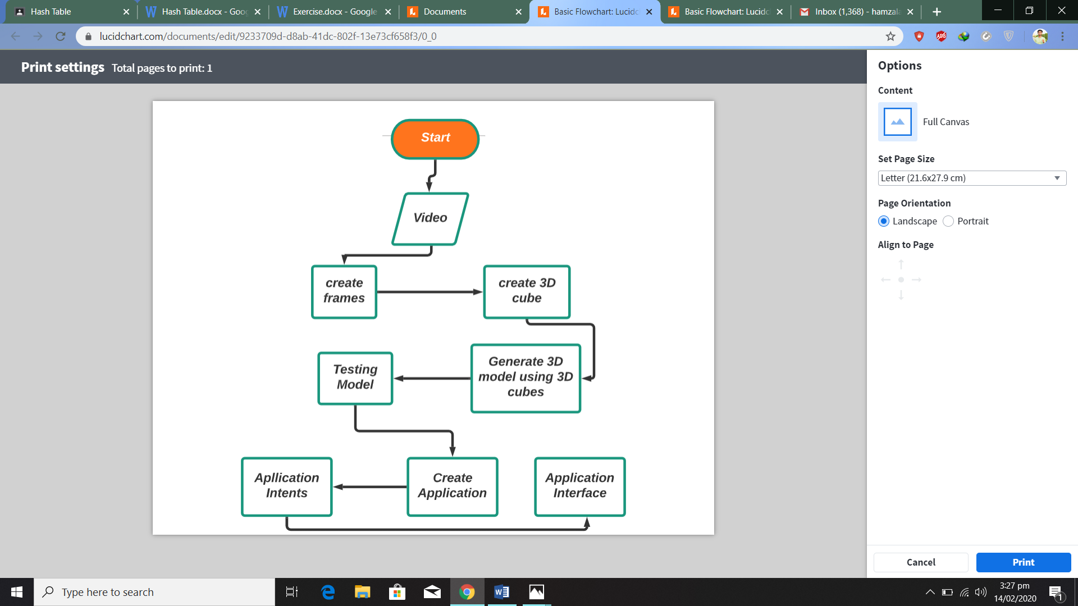

Figure 2: Basic Working Flowchart of our Architecture

Application design will be quite simple, innovative and user friendly. Application will detect different violations in videos and will pop up a message or alarm to pin point the event. This will make easier for operator to differentiate between the violation event and other activities happening in the video.

## Goals and Objectives

* The project aims to automate the traffic rules violation detection system and make it convenient for the traffic police department to monitor the traffic and take action against the violated vehicle owner in a fast and efficient way. Detecting and recognizing the vehicle and their activities accurately is the main priority of the system.
* We want to design a generic model that would cover many separate related projects like Sensor less red light violation detection system [11] and Vehicle detection and counting system based on vision [12]
* Also we want to overcome the human errors in video surveillance
* Recently working traffic architecture are not so precise and results aren’t that much clear to investigate the driver. It only gathers vehicle info, so we want to cover all the flaws present in previous system

## Individual Tasks

*Table 1: Division of work of the project.*

|  |  |
| --- | --- |
| **Hamza Latif** | **Hassan Sharjeel** |
| Designing 3D model | Data gathering |
| Analysis available datasets | Testing 3D model |
| Training 3D model using datasets | Application Back-end designing |
| Application Front-end designing | Embed 3D model with application |
| Integration Testing | Bugs Fixing |
| Documentation | Analysis |

## Gantt Chart

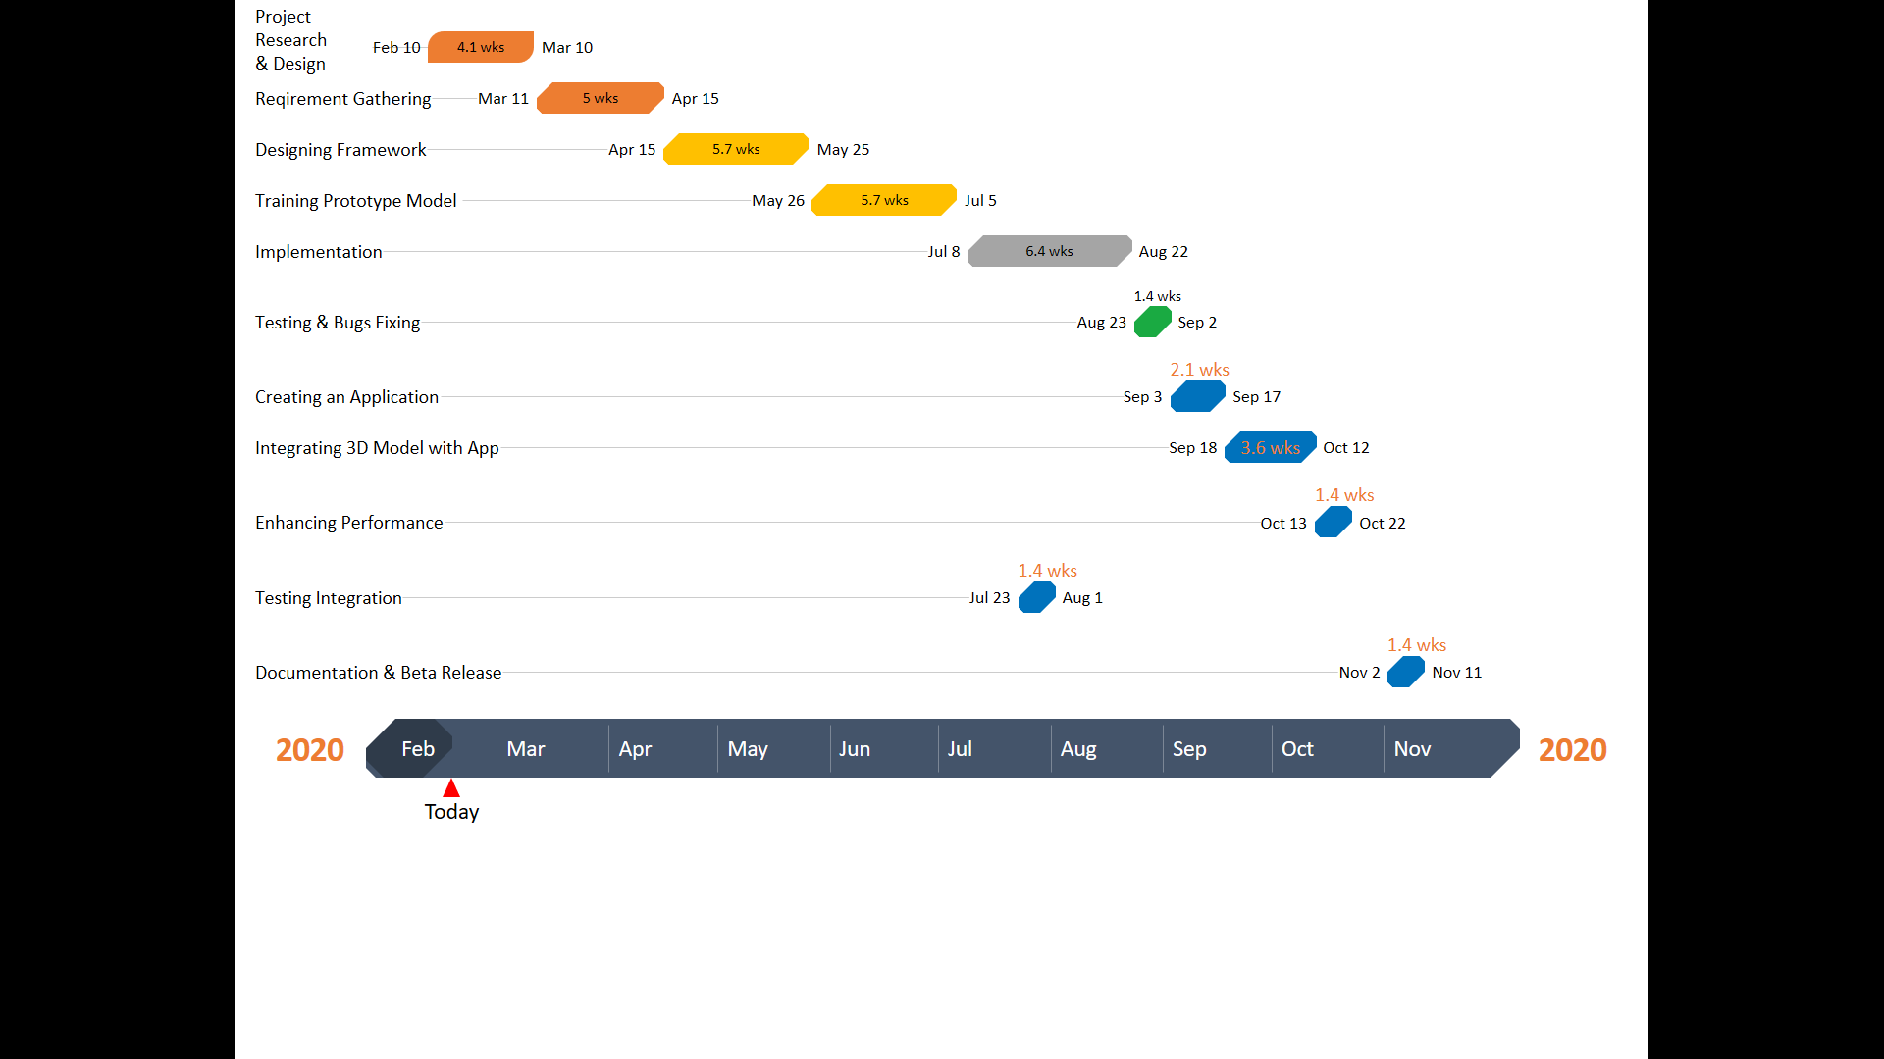

## Tools and Technologies

• **Languages:** C/C++, Python, Java.

• **IDEs:**  Android Application,Anaconda, Spyder, PYCharm.

• **Libraries:** OpenCv, Firebase, TensorFlow, Pytorch.

# References

|  |  |
| --- | --- |
| [1] | S. K. H. Kazmi, “Pakistan And Gulf Economist,” news,research, 11 2017. [Online]. Available: http://www.pakistaneconomist.com/2017/11/13/alarming-road-accidents-rate-pakistan-rules-laws-need-overhaul/. [Accessed 14 2 2020]. |
| [2] | C. Wang, S. Ison and M. Quddus, “Impact of traffic congestion on road accidents: A spatial analysis of the M25 motorway in England,” *Accident; analysis and prevention,* p. 12, 2009. |
| [3] | D. Deme and M. Bari, “Traffic Accident Causes and Its Countermeasures on Addis Ababa-Adama Expressway,” *Journal of Equity in Science and Sustainable Development,* p. 12, 2016. |
| [4] | V. .B*, and M. Babu, “Dynamic Traffic- Rule- Violation Monitoring and Detection System,” *IJESRT,* p. 14, 2014. |
| [5] | “Telegra,” Smart Traffic Mangement , [Online]. Available: https://www.telegra-europe.com/products/product_category-1/product-580. [Accessed 12 February 2020]. |
| [6] | M. Bramberger, J. Brunner and B. Rinner, “Real-Time Video Analysis on an Embedded Smart Camera,” *10th IEEE Real-Time and Embedded Technology and Applications Symposium,* p. 11, 2004. |
| [7] | S. Kamijo, Y. Matsushita, K. Ikeuchi and M. Sakauchi, “Traffic Monitoring and Accident Detection at,” *IEEE Transactions on Intelligent Transportation Systems,* vol. 1, p. 20, 2000. |
| [8] | A. mariya T.P, A. M.J, F. Aishwarya and L. George, “TRAFFIC VIOLATION DETECTION SYSTEM,” *Traffic Enforcement System,* vol. 4, no. 03, p. 4, 2017. |
| [9] | J. Zhang and T. Shi, “Spatial analysis of traffic accidents based on WaveCluster and vehicle communication system data,” *EURASIP Journal on Wireless Communications and Networking,* p. 20, 2019. |
| [10] | P. G. M. R. A. and . F. , “Vehicle detection through image processing for traffic surveillance and control,” *MINNESOTA A CORP OF MINNESOTA,* 2017. |
| [11] | N. S. Bayindir, H. Demirel and H. Kusetogullari, “A sensorless red light violation detection system using image processing,” *RED LIGHT VIOLATION DETECTION SYSTEM ,* p. 7, 2007. |
| [12] | H. Song, H. Liang, H. Li and Z. Dai, “Vision-based vehicle detection and counting system using deep learning in highway scenes,” *European Transport Research Review,* p. 13, 2019. |

